Global Cosmic Calibration and the Cosmic Clock Framework

Ancient Astronomical Alignments as a Distributed Timekeeping System
Author: Gabino Casanova
Year: 2026

Abstract
Ancient civilizations across multiple continents constructed architectural systems aligned with recurring celestial events, particularly solar, lunar, and stellar cycles. This paper presents a unified interpretation of these systems as distributed analog calibration nodes synchronized through shared astronomical constraints. By incorporating both classical and recently studied archaeological sites, including Caral, Sanxingdui, and Amazonian geoglyph complexes, this study expands the global dataset of astronomical alignment. A modern interpretive layer, referred to as the Cosmic Clock framework and grounded in Curvature Synchronization Theory (CST), is introduced to describe these systems as observer-dependent time-synchronization mechanisms.

Introduction: The Sky as a Universal Reference System
Before mechanical timekeeping, civilizations relied on the predictable motion of celestial bodies. The Sun, Moon, and stars provided a stable reference framework for agriculture, navigation, and ritual systems. Structures such as the Great Pyramid of Giza and Stonehenge demonstrate precise alignment with celestial cycles.

Global Dataset of Astronomical Sites
Site | Latitude | Longitude | Age | Alignment | Function
Great Pyramid of Giza | 29.9792° N | 31.1342° E | ~2600 BCE | Cardinal / stellar | Solar and ritual
Stonehenge | 51.1789° N | -1.8262° W | ~3000–2000 BCE | Solstitial solar | Seasonal tracking
Chichén Itzá | 20.6843° N | -88.5678° W | ~600–1200 CE | Equinox solar | Agricultural cycles
Göbekli Tepe | 37.2231° N | 38.9226° E | ~9600 BCE | Possible stellar | Ceremonial
Çatalhöyük | 37.6670° N | 32.8260° E | ~7500 BCE | Solar symbolic | Seasonal
Caral | -10.8926° S | -77.5200° W | ~2600 BCE | Solar horizon | Agricultural
Sanxingdui | 31.0000° N | 104.0000° E | ~1200 BCE | Stellar symbolic | Ritual
Amazon Geoglyphs | -9.974° S | -67.810° W | ~0–2000 CE | Cardinal geometry | Environmental

Diagram — Global Distribution (Small Reference)
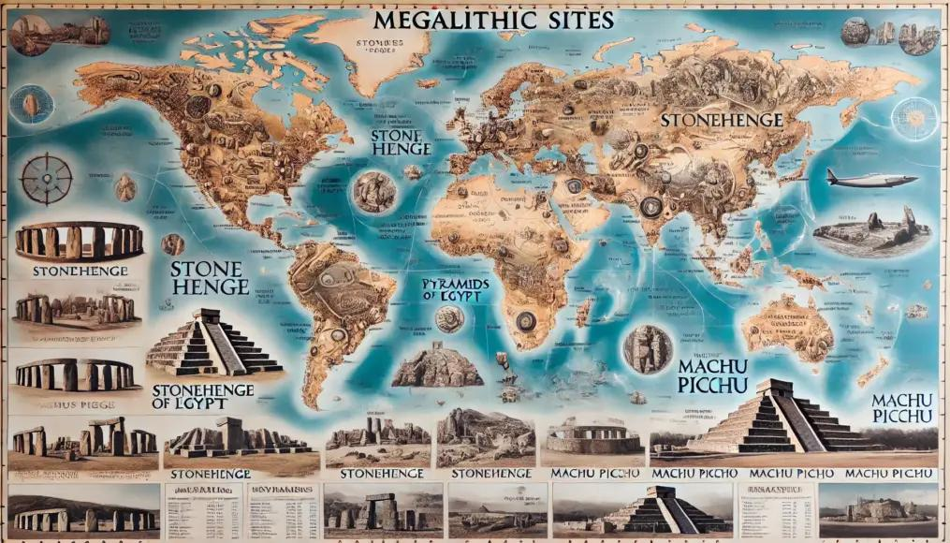
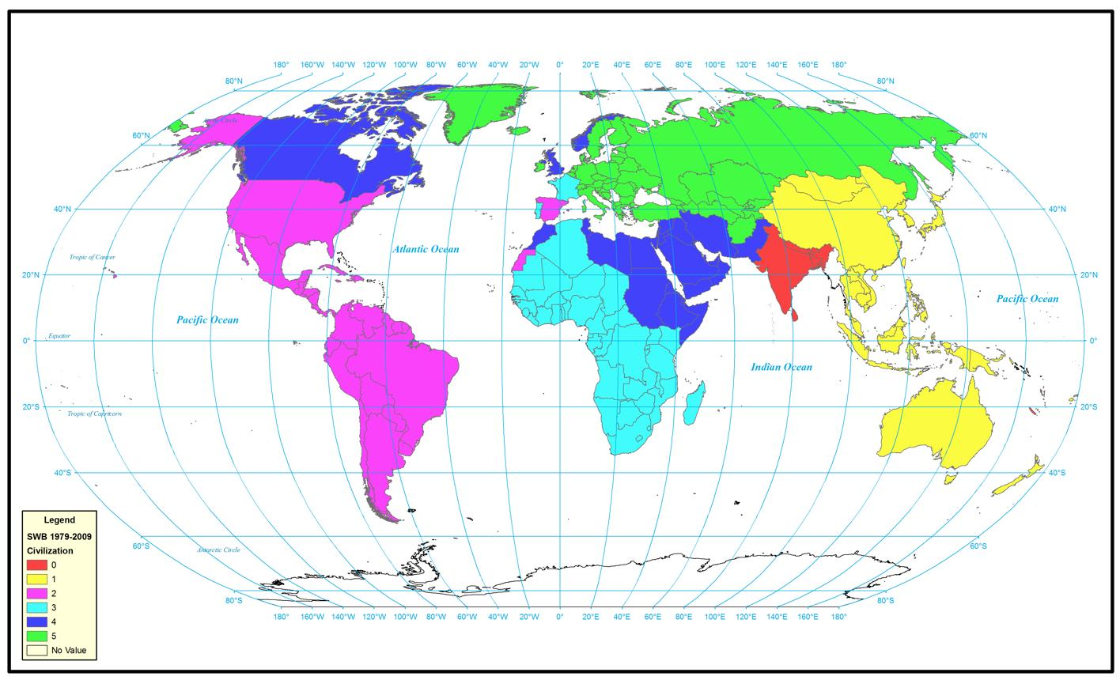

Astronomical Reference Systems
Solar alignment is the dominant global standard, defining equinox and solstice cycles. Lunar and stellar systems provide secondary calibration layers.

Diagram — Solar–Lunar–Stellar Geometry (Compact)
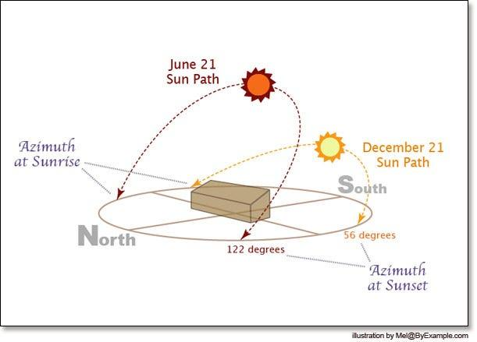
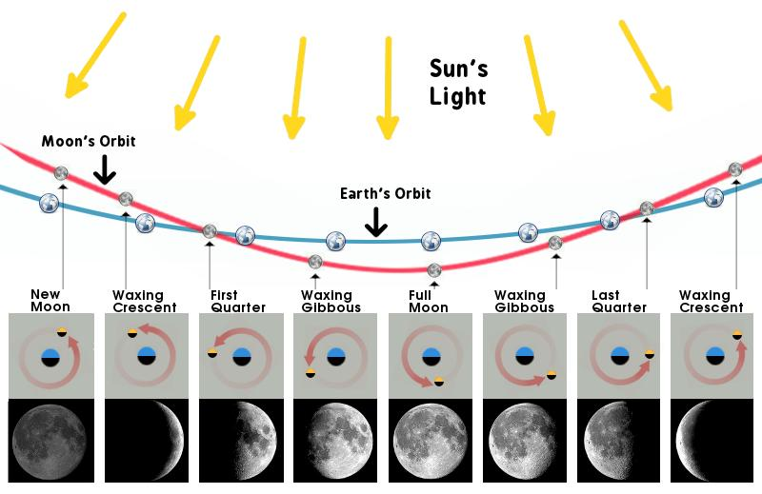


Gnomon Geometry and Spatial Calibration
The gnomon allowed early civilizations to determine cardinal directions and establish alignment grids through shadow tracking.

Diagram — Gnomon Shadow (Compact)
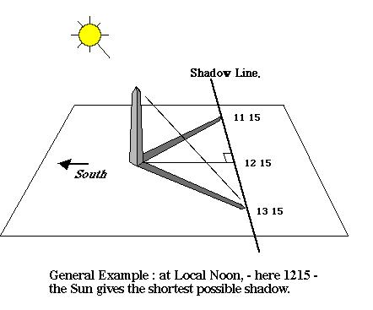
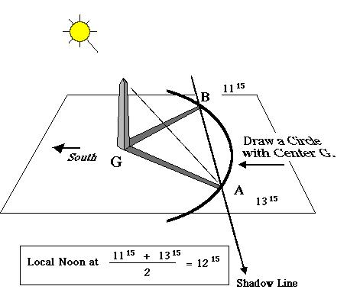
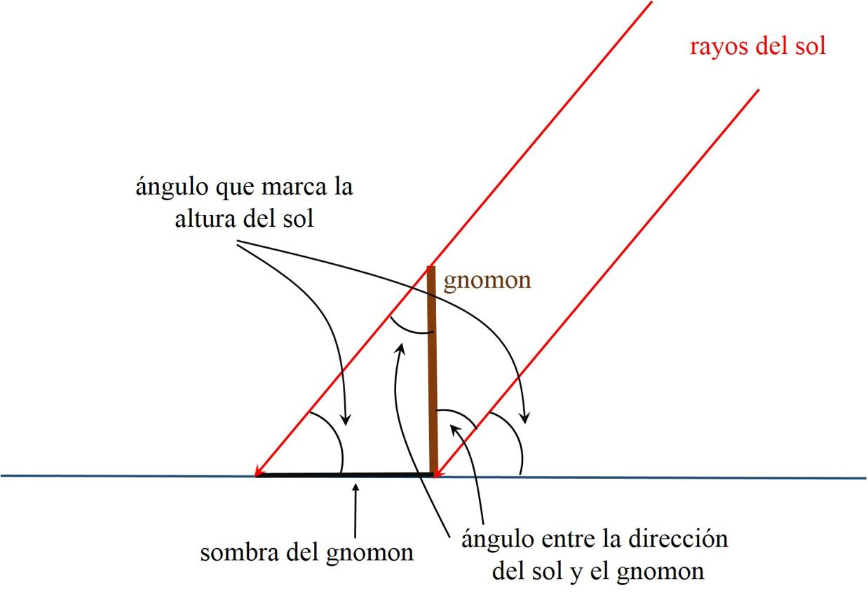

Quantitative Solar Framework
Solar elevation follows predictable geometry:
$$h={90}^{∘}-∣ϕ-δ∣$$
At equinox:
$$h={90}^{∘}-∣ϕ∣$$

Diagram — Latitude vs Solar Angle (Compact)
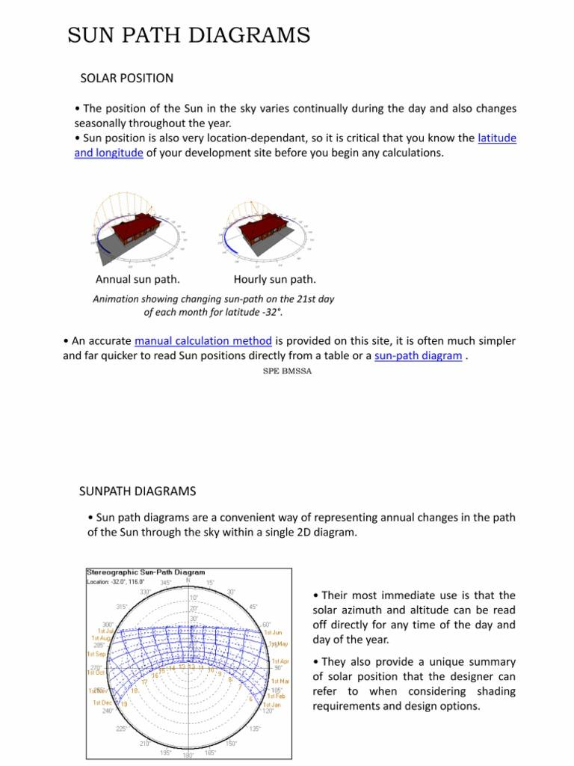

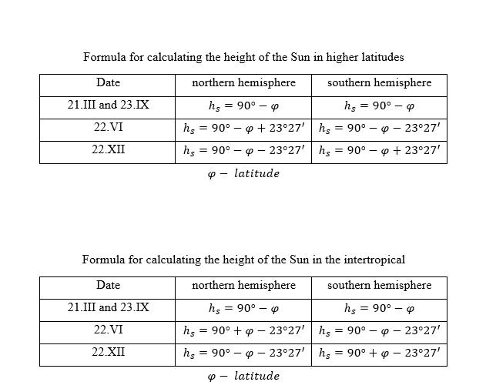

Observer-Dependent Stellar Mapping and Local Cosmic Clocks
Ancient civilizations observed different versions of the sky depending on their geographic position. Each location produced a unique celestial map based on visible stars.

Diagram — Sky Dome by Latitude (Key Concept)
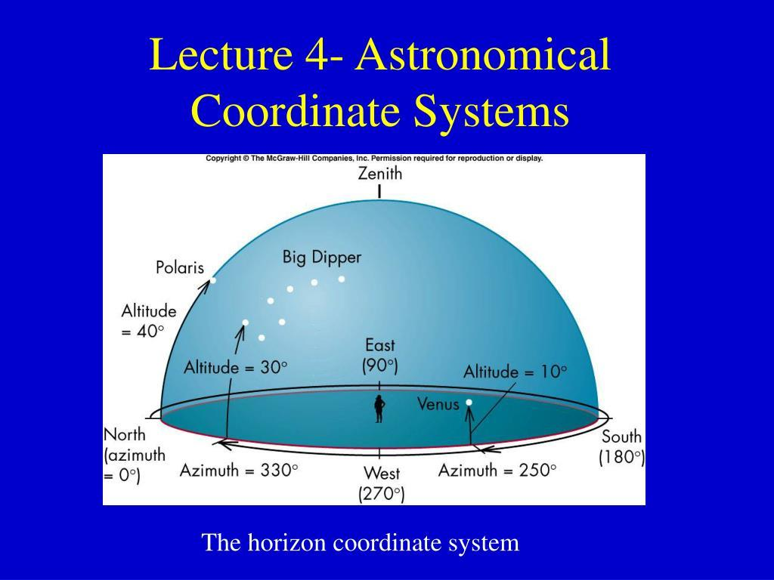
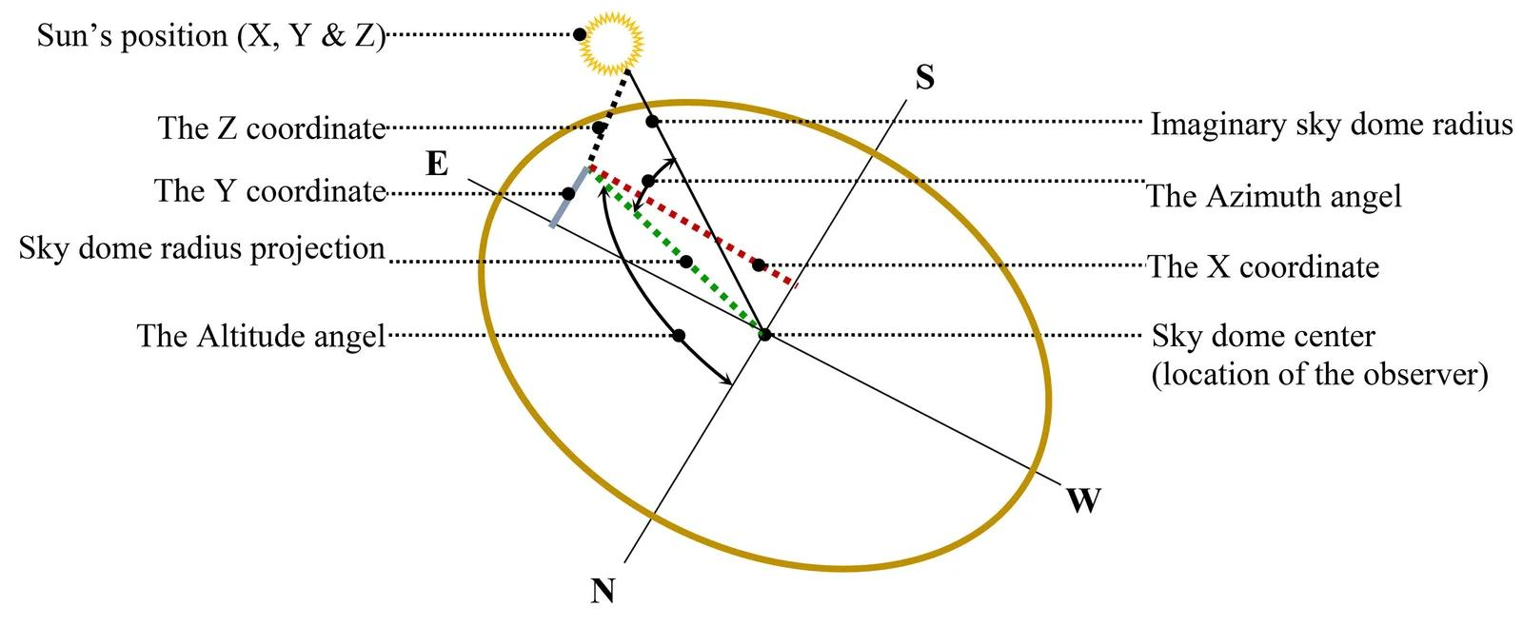
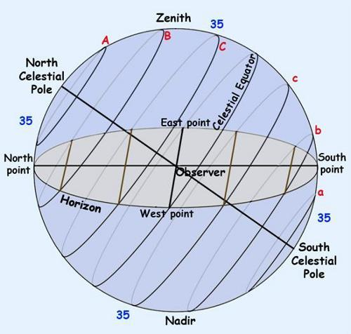
From each site:
- A 360° horizon defines the visible sky
- Stars appear and disappear with latitude
- Each civilization builds its own star map

Local Stellar Anchor Systems

Northern Anchor
- Polaris serves as a fixed reference in northern regions
- Observed at sites such as Great Pyramid of Giza and Stonehenge

Rotating Star Anchors
- Vega
- Deneb
- Altair
These form rotating patterns that change orientation depending on location.

Diagram — Rotating Star Patterns (Compact)

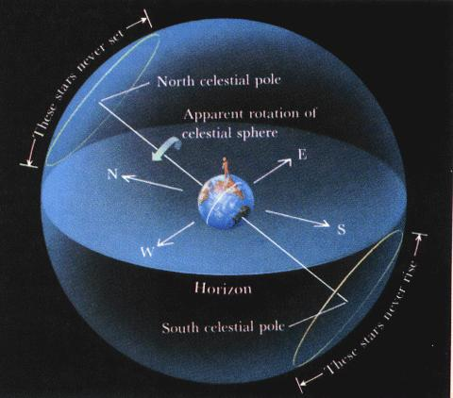

4

Equatorial and Southern Systems
At locations such as Caral and Amazonian regions:
- Polaris disappears
- Southern constellations dominate
- Solar horizon tracking becomes primary

Diagram — Northern vs Southern Sky (Compact)
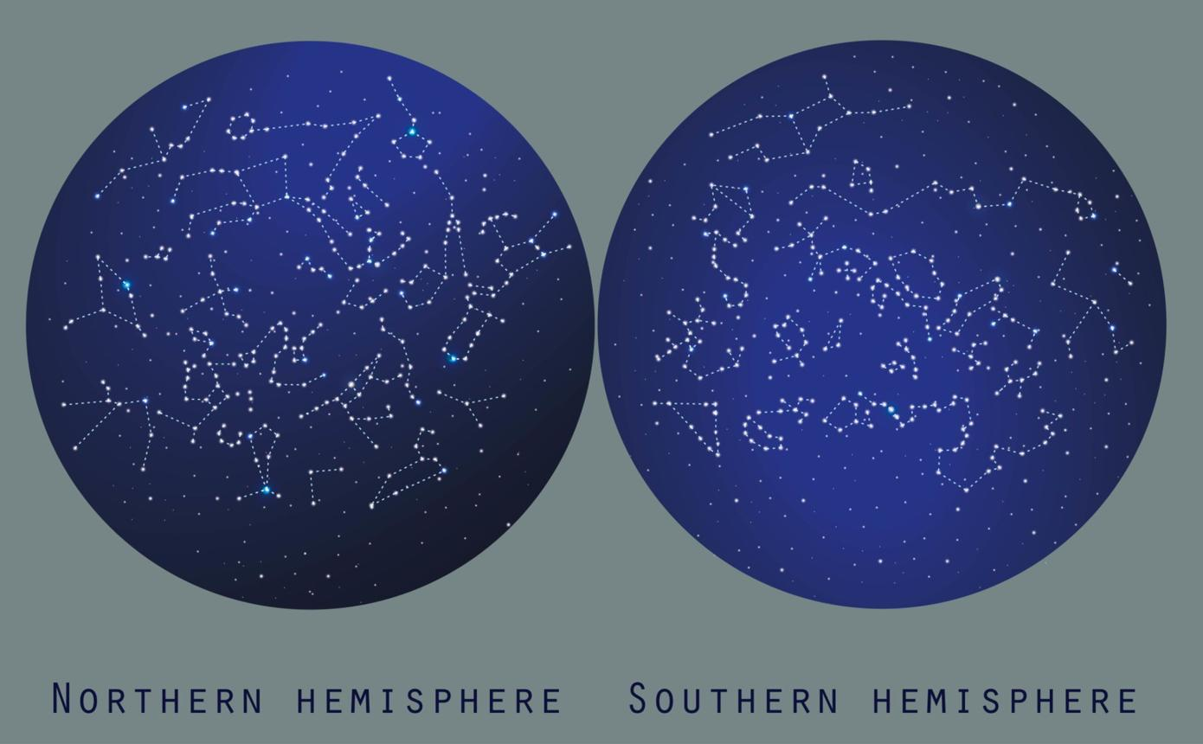
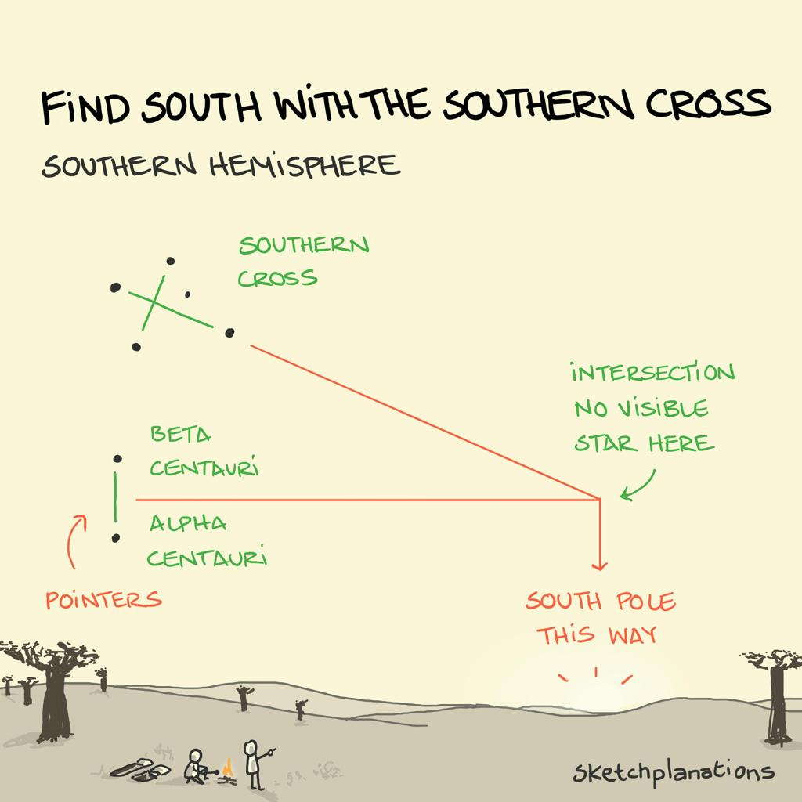
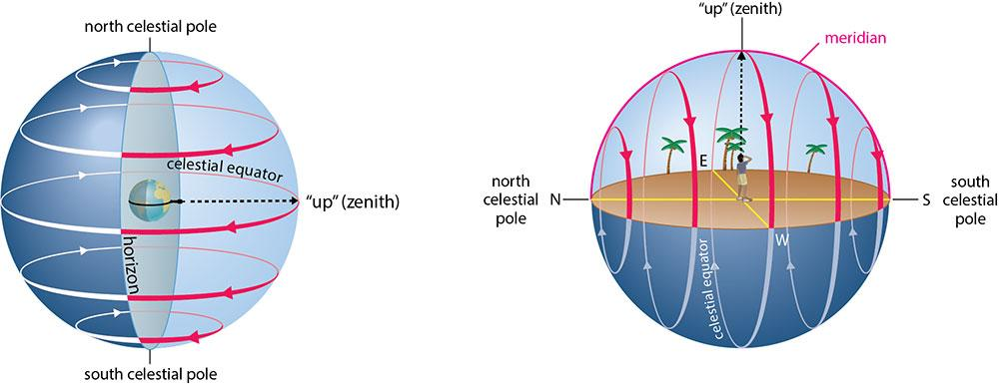

Dynamic Line-of-Sight Connectivity
A key insight is that stars do not form fixed connections globally. Instead:
- Bright stars act as visual anchors
- Surrounding stars shift based on observer position
- Each civilization sees a different star network

Diagram — Line-of-Sight Star Connections (Key)
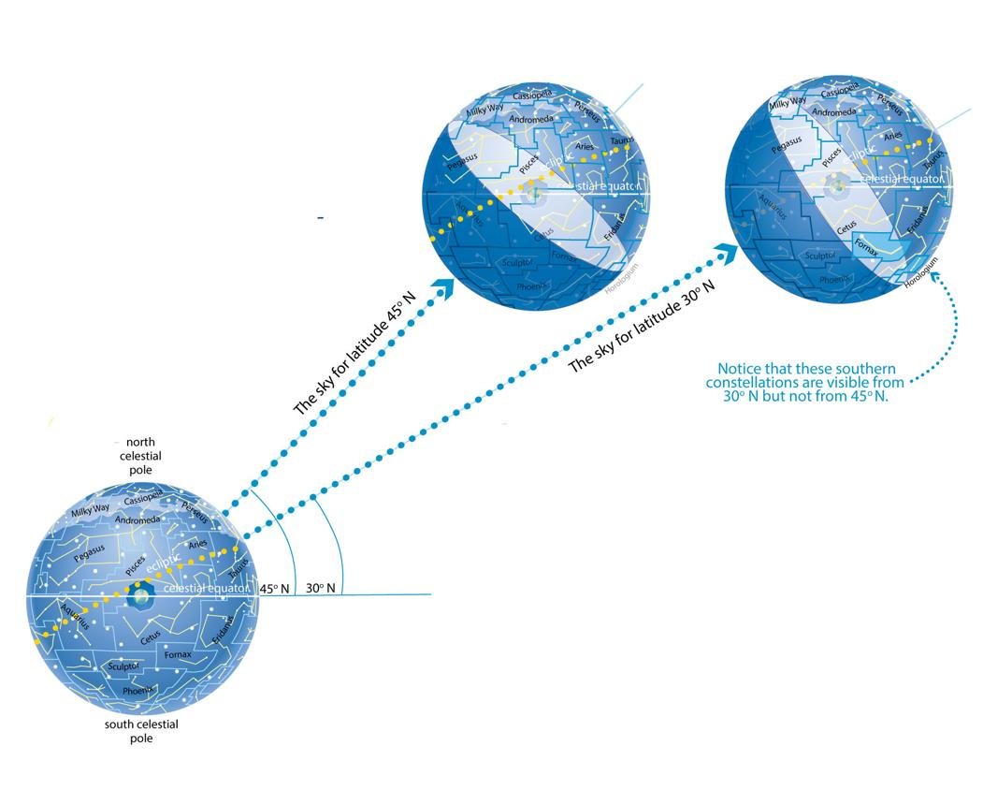
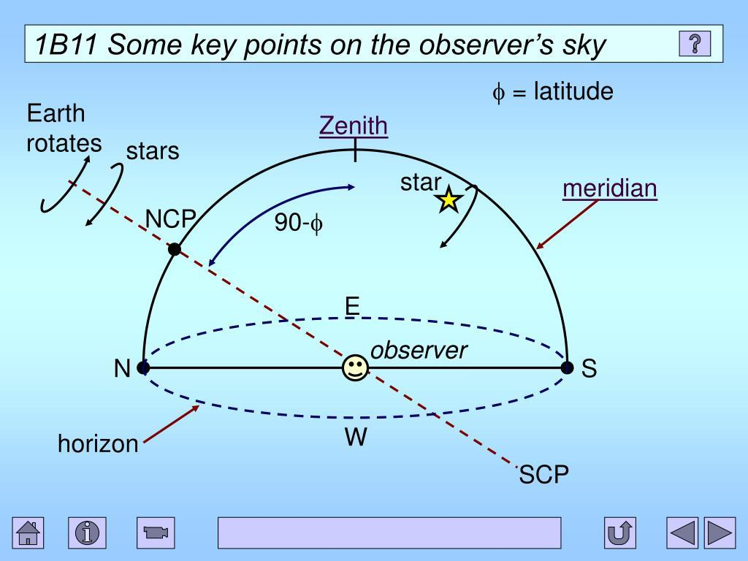

The Cosmic Clock Framework
Each civilization operates a local timing system based on celestial observation.
$$ΔT=T_{local}-T_{celestial}$$
Where time is calculated through:
- Solar cycles
- Stellar motion
- Horizon alignment

Diagram — Distributed Cosmic Clock (Compact)

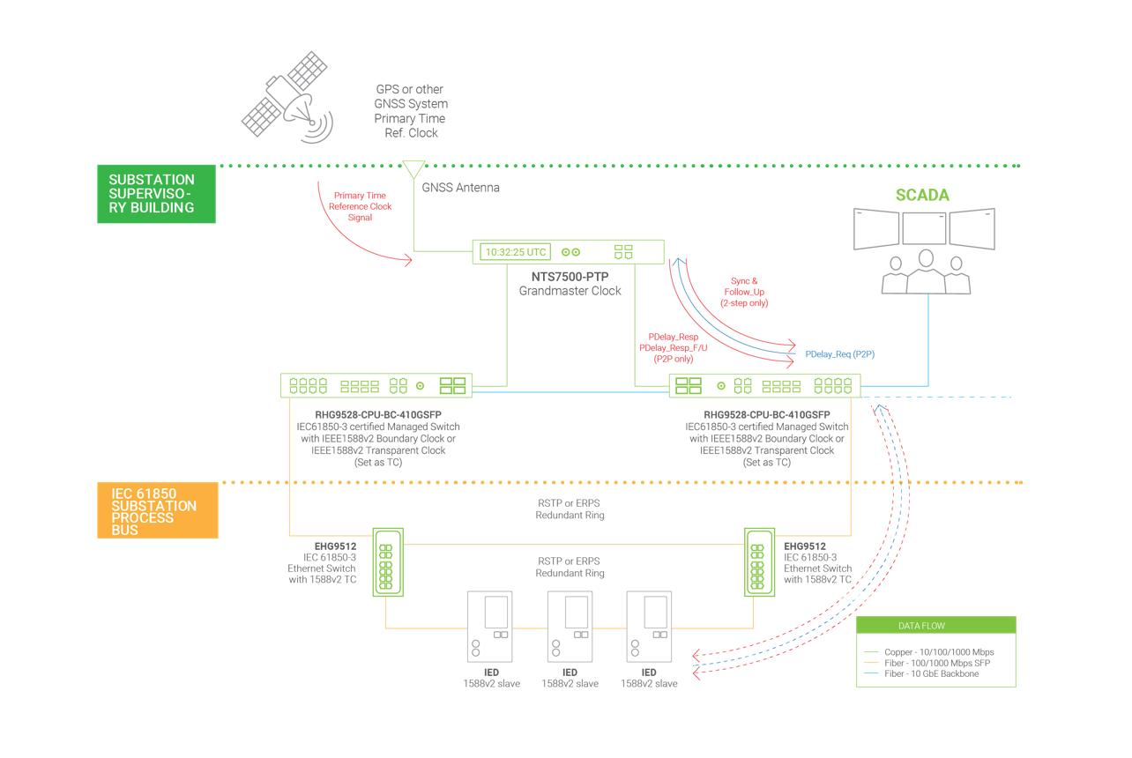

Synthesis
Ancient civilizations did not share identical star maps. Instead, they shared:
- A method of observation
- A geometric framework
- A reliance on celestial cycles
Each location produced its own astronomical identity, shaped by:
- Latitude
- Horizon
- Visible stars

Conclusion
Ancient astronomical systems represent a distributed network of local observers, each constructing a unique map of the sky while referencing the same celestial structure. These systems functioned as analog timekeeping mechanisms calibrated through repeated observation. The Cosmic Clock framework provides a modern interpretation of this process, describing time as a locally maintained variable synchronized to a shared cosmic reference.

References
The Oxford Handbook of Archeoastronomy and Ethnoastronomy
Anthony Aveni
Gerald Hawkins
Ruggles, C. Handbook of Archeoastronomy
Magli, G. Architecture, Astronomy and Sacred Landscape

